Panaligan, Judy A.
BSIT 2-F1

Exercise 1.
- Create database addresssbook.
- Describe table_name
- Show databases
- Insert into table_name values (‘Rudolf’, ‘Reindeer’, ‘Business Analysts’, 34, 2, 95000, 17000, ‘rudolf@bugnet.com’)
- Select * from employee_data
Select First_Name, Last_Name, Title, Age, Years, Salary, Perks, Email from employee_data
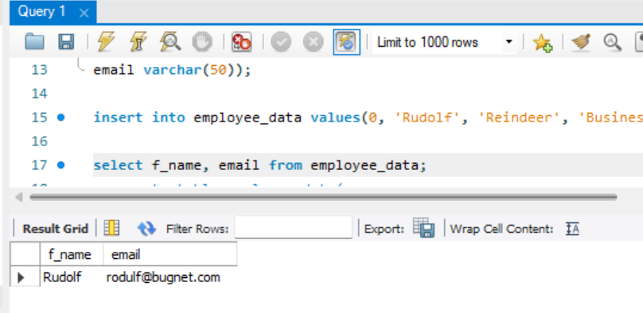

- Select salary, perks, yos From employee_data
- Select count(*) From employee_data

